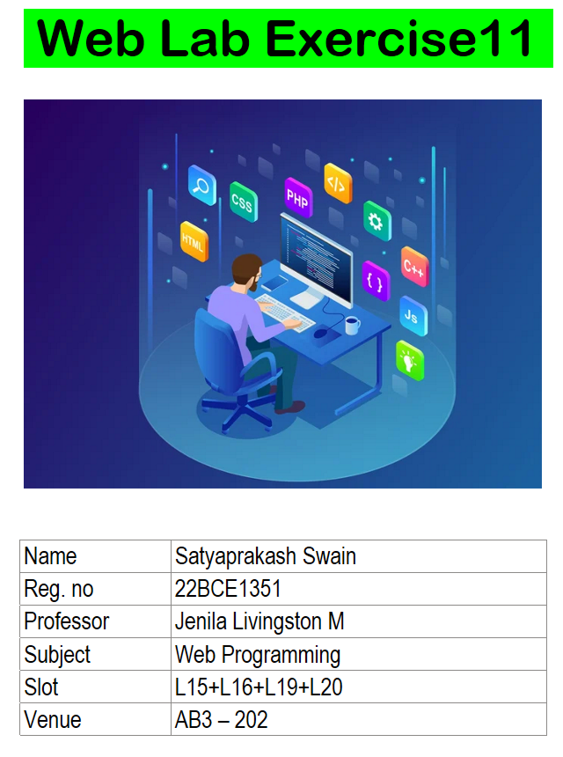

**1.** Write a JavaScript to

(i) Create a dynamic table with three rows and three columns

(ii) Change the color of the Button from red to green color on Mouse Over.

(iii)Change the color of the Textbox from green to yellow color on Focus and display a

greeting message on Change

Note: Both button and textbox should be created using CreateElement

(iv) Create an input field and a button. When the button is double clicked, add the input text

as a new <li> item to an unordered list.

(v) Create two input fields: one for accepting input and another for counting and displaying

the number of times any key is pressed.

**CODE:**

<!DOCTYPE html>

<html lang="en">

<head>

<meta charset="UTF-8">

<meta name="viewport" content="width=device-width, initial-scale=1.0">

<title>22BCE1351</title>

</head>

<body>

<script>

*const* newline = document.createElement('br');

*const* table = document.createElement("table");

table.style.border = "1px solid black";

table.style.margin = "20px 0";

table.style.borderCollapse = "collapse";

for (*let* i = 0; i < 3; i++) {

*const* row = document.createElement("tr");

for (*let* j = 0; j < 3; j++) {

*const* cell = document.createElement('td');

cell.textContent = `${i} ${j}`;

cell.style.border = "1px solid black"

cell.style.padding = '8px';

row.appendChild(cell);

}

table.appendChild(row);

}

document.body.appendChild(table);

*const* button = document.createElement("button");

button.textContent = 'Hello';

button.style.backgroundColor = "red";

button.style.color = "white";

button.style.padding = '10px 20px';

button.style.margin = '10px';

button.addEventListener('mouseover', () => {

button.style.backgroundColor = 'green';

})

document.body.appendChild(button);

*const* textBox = document.createElement("input");

textBox.style.backgroundColor = 'green';

textBox.style.color = 'black';

textBox.style.padding = '8px';

textBox.style.margin = '10px';

textBox.addEventListener('focus', () => {

textBox.style.backgroundColor = "yellow";

})

textBox.addEventListener('change', () => {

alert(`Hello ${textBox.value}`);

})

document.body.appendChild(textBox);

*const* inputField = document.createElement('input');

inputField.type = 'text';

inputField.style.margin = '10px';

*const* addButton = document.createElement('button');

addButton.textContent = 'Add to List';

addButton.style.margin = '10px';

*const* list = document.createElement('ul');

addButton.addEventListener('dblclick', () => {

*const* item = document.createElement('li');

item.textContent = `${inputField.value}`;

list.appendChild(item);

})

document.body.appendChild(newline);

document.body.appendChild(inputField);

document.body.appendChild(addButton);

document.body.appendChild(list);

*const* inputfield = document.createElement('input');

inputfield.type = 'text';

inputfield.style.margin = '10px';

*const* outputfield = document.createElement('input');

outputfield.type = 'text';

outputfield.readOnly = true;

outputfield.style.margin = '10px';

*let* count = 0;

inputfield.addEventListener('keydown', () => {

count++;

outputfield.value = count;

})

document.body.appendChild(inputfield);

document.body.appendChild(outputfield);

</script>

</body>

</html>

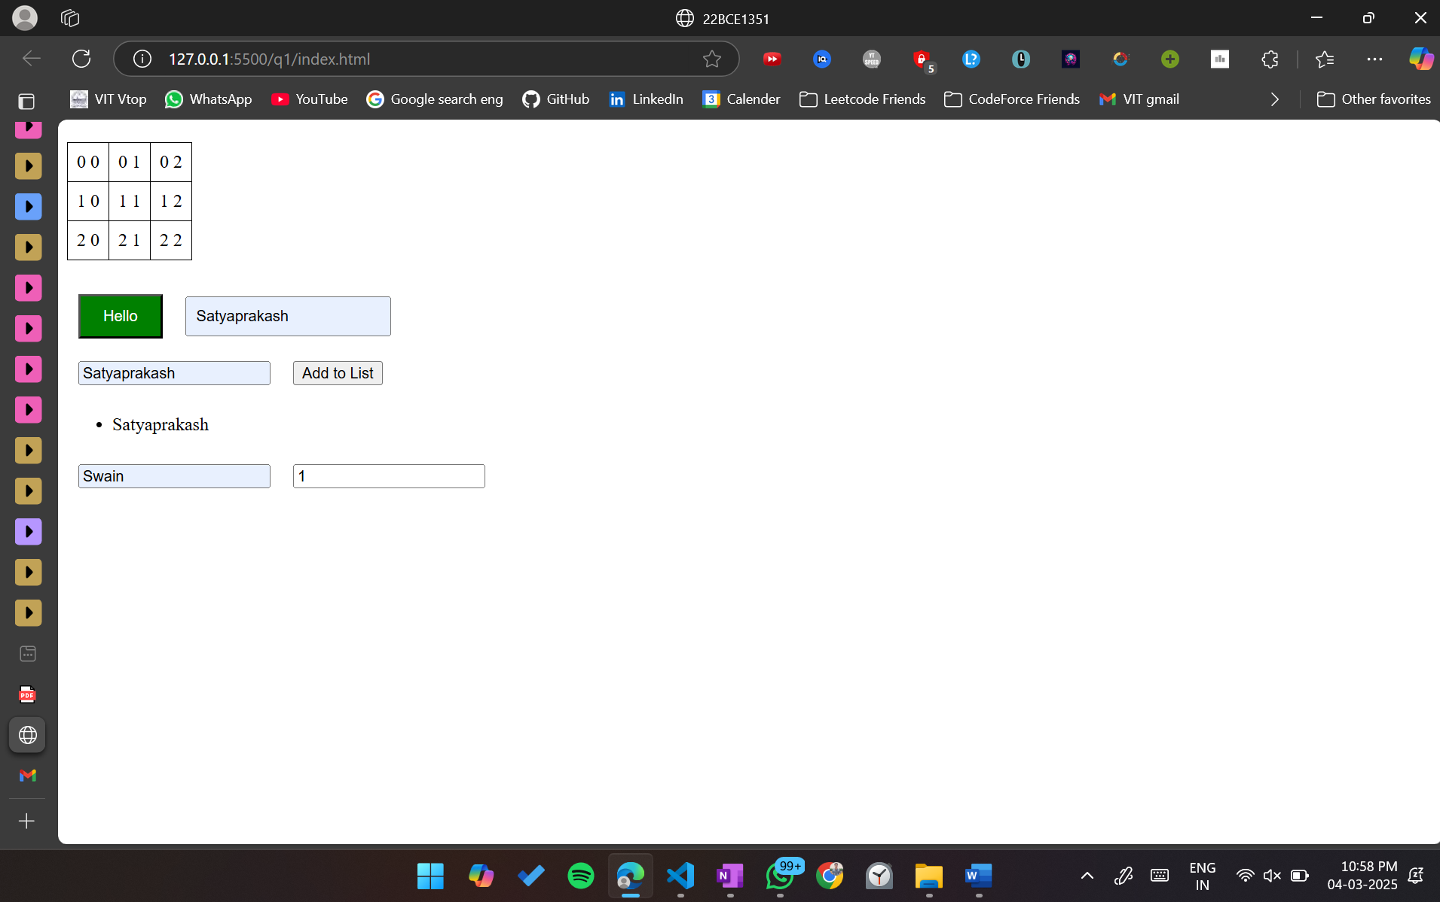

**2.** (i) Create a simple stopwatch with "Start", "Stop", and "Reset" buttons using JavaScript

event listeners.

(ii) Create a text box to accept the Date of Birth and calculate the age on mouseover using an

event listener.

(iii) Create a textarea with a character counter that updates dynamically as the user types

using an event listener

**CODE:**

<!DOCTYPE html>

<html lang="en">

<head>

<meta charset="UTF-8">

<meta name="viewport" content="width=device-width, initial-scale=1.0">

<title>22BCE1351</title>

</head>

<body>

<script>

*const* container = document.createElement('div');

container.style.margin = "20px";

container.style.textAlign = 'center'

*const* timer = document.createElement('div');

timer.textContent = "00:00:00";

timer.style.fontSize = '24px';

timer.style.marginBottom = '10px';

container.appendChild(timer);

*const* startBtn = document.createElement('button');

startBtn.textContent = 'Start';

startBtn.style.margin = '5px';

*const* stopBtn = document.createElement('button');

stopBtn.textContent = "Stop";

stopBtn.style.margin = '5px';

*const* resetBtn = document.createElement('button');

resetBtn.textContent = "Reset";

resetBtn.style.margin = '5px'

*let* start = 0;

*let* curr = 0;

*let* timeInterval = 0;

function formatTime(ms) {

*const* minutes = Math.floor(ms / 60000);

*const* seconds = Math.floor((ms % 60000) / 1000);

*const* millis = Math.floor(ms % 1000);

*return* `${String(minutes).padStart(2, '0')}:${String(seconds).padStart(2, '0')}:${String(millis).padStart(3, '0')}`;

}

startBtn.addEventListener('click', () => {

start = Date.now() - curr;

timeInterval = setInterval(() => {

curr = Date.now() - start;

timer.textContent = formatTime(curr);

}, 10)

})

stopBtn.addEventListener('click', () => {

clearInterval(timeInterval);

})

resetBtn.addEventListener('click', () => {

clearInterval(timeInterval);

timer.textContent = "00:00:00";

})

container.append(startBtn, stopBtn, resetBtn);

document.body.appendChild(container);

*const* dobInp = document.createElement('input');

dobInp.type = 'date';

dobInp.style.margin = '5px';

dobInp.style.padding = '20px';

*const* ageDisplay = document.createElement('div');

ageDisplay.style.fontSize = '18px';

ageDisplay.style.marginLeft = '20px';

dobInp.addEventListener('mouseover', () => {

*const* d = new Date();

*let* inp = dobInp.valueAsDate;

*let* value = d.getFullYear() - inp.getFullYear();

if (d.getMonth() < inp.getMonth() || (d.getMonth() === inp.getMonth() && d.getDate() < inp.getDate())) {

value--;

}

ageDisplay.textContent = `Age: ${value}`;

})

document.body.appendChild(dobInp);

document.body.appendChild(ageDisplay);

*const* textArea = document.createElement('textarea');

textArea.style.width = '300px';

textArea.style.height = '100px';

textArea.style.margin = '20px';

*const* counter = document.createElement('div');

counter.style.marginLeft = '20px';

counter.textContent = 'Characters typed: 0';

textArea.addEventListener('keydown', () => {

*const* val = textArea.value.length;

counter.textContent = `Characters typed: ${val}`;

});

document.body.appendChild(textArea);

document.body.appendChild(counter);

</script>

</body>

</html>

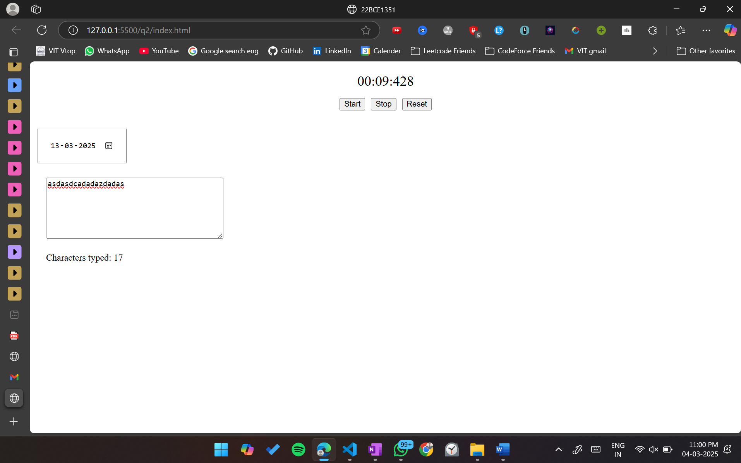

**3.** Design the below form and do the following(i) Set the timer to display the current time

(ii) Print the form content. Use getElementsByName to display Gender, Country and

Preferences

(iii)Validate

(a) All Mandatory Fields (represented by *). If empty focus on the same field.

(b) Name should not exceed 15 characters

(c) Address – to be specified in Text Area

(d) Zip code should be numeric and validated the maximum digits

(e) Phone numbers should be numeric and validated the maximum digits 10

(f) e-mail syntax should be validated

(g) Password should contain a number, character & a special character and length should

not exceed 15 and recede 8

(h) PAN card number – Textbox (validate such that the PAN number is 10 digits and

follows the pattern)

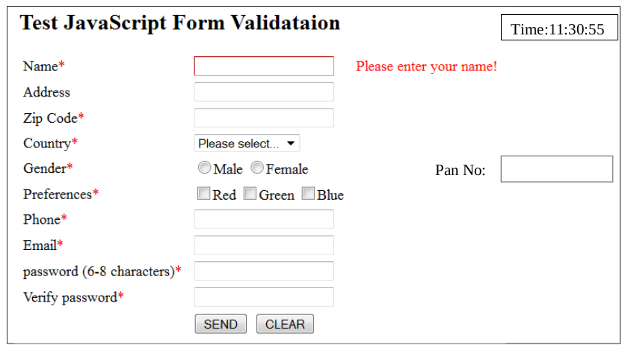

**CODE:**

1. **index.html**

<!DOCTYPE html>

<html lang="en">

<head>

<meta charset="UTF-8">

<meta name="viewport" content="width=device-width, initial-scale=1.0">

<title>22BCE1351</title>

<style>

form {

border-color: black;

border-style: solid;

border-width: 1px;

}

label {

*/* display: block; */*

margin-top: 10px;

}

.header {

display: flex;

justify-content: space-between;

align-items: center;

}

.error {

color: red;

font-size: 0.9em;

}

</style>

</head>

<body>

<form id="myform" onsubmit="validateForm(event)">

<div class="header">

<h2>Test JavaScript Form Validation</h2>

<div id="timer">00:00</div>

</div>

<label>Name*</label>

<input type="text" name="name" id="name" maxlength="15">

<span id="nameError" class="error"></span>

<br><br>

<label for="address">Address</label>

<textarea id="address" name="address"></textarea>

<br><br>

<label for="zipCode">Zip Code*</label>

<input type="text" id="zipCode" name="zipCode">

<br><br>

<label for="country">Country*</label>

<select name="country" id="country">

<option value="">Please Select</option>

<option value="USA">USA</option>

<option value="India">India</option>

</select>

<br><br>

<label for="gender">Gender*</label>

<input type="radio" id="male" name="gender" value="Male">

<label for="male">Male</label>

<input type="radio" id="female" name="gender" value="Female">

<label for="female">Female</label>

<br><br>

<label for="preferences">Preferences*</label>

<input type="checkbox" id="red" name="preferences" value="Red">

<label for="red">Red</label>

<input type="checkbox" id="green" name="preferences" value="Green">

<label for="green">Green</label>

<input type="checkbox" id="blue" name="preferences" value="Blue">

<label for="blue">Blue</label>

<br><br>

<label for="phone">Phone*</label>

<input type="text" id="phone" name="phone" maxlength="10">

<br><br>

<label for="email">Email*</label>

<input type="text" id="email" name="email">

<br><br>

<label for="password">Password (6-8 characters)*</label>

<input type="password" id="password" name="password" minlength="8">

<br><br>

<label for="verifyPassword">Verify Password*</label>

<input type="password" id="verifyPassword" name="verifyPassword" minlength="8">

<br><br>

<label for="panNo">PAN No:</label>

<input type="text" id="panNo" name="panNo">

<br><br>

<button type="submit">SEND</button>

<button type="button" onclick="clearForm()">CLEAR</button>

</form>

<script src="script.js"></script>

</body>

</html>

1. **script.js**

function updateTimer() {

*const* now = new Date();

*const* timeString = now.toLocaleTimeString();

document.getElementById('timer').innerText = `Time: ${timeString}`;

}

setInterval(updateTimer, 1000);

function clearForm() {

document.getElementById('testForm').reset();

}

function validateForm(event) {

event.preventDefault();

*let* isValid = true;

*const* name = document.getElementsByName('name')[0];

if (!name.value) {

document.getElementById('nameError').innerText = 'Please enter your name!';

name.focus();

isValid = false;

} else {

document.getElementById('nameError').innerText = '';

}

*const* zipCode = document.getElementsByName('zipCode')[0];

if (!zipCode.value || isNaN(zipCode.value) || zipCode.value.length > 5) {

alert('Invalid Zip Code!');

zipCode.focus();

isValid = false;

}

*const* phone = document.getElementsByName('phone')[0];

if (!phone.value || isNaN(phone.value) || phone.value.length !== 10) {

alert('Invalid Phone Number!');

phone.focus();

isValid = false;

}

*const* email = document.getElementsByName('email')[0];

*const* emailRegex = /^[^\s@]+@[^\s@]+\.[^\s@]+$/;

if (!email.value || !emailRegex.test(email.value)) {

alert('Invalid Email!');

email.focus();

isValid = false;

}

*const* password = document.getElementsByName('password')[0];

*const* verifyPassword = document.getElementsByName('verifyPassword')[0];

*const* passwordRegex = /^(?=.*[0-9])(?=.*[a-zA-Z])(?=.*[!@#$%^&*])[a-zA-Z0-9!@#$%^&*]{8,15}$/;

if (!password.value || !passwordRegex.test(password.value) || password.value !== verifyPassword.value) {

alert('Invalid Password!');

password.focus();

isValid = false;

}

*const* panNo = document.getElementsByName('panNo')[0];

*const* panRegex = /^[A-Z]{5}[0-9]{4}[A-Z]$/;

if (panNo.value && !panRegex.test(panNo.value)) {

alert('Invalid PAN Number!');

panNo.focus();

isValid = false;

}

if(isValid)printFormContent();

}

function printFormContent() {

*const* name = document.getElementById('name').value;

*const* address = document.getElementById('address').value;

*const* zipCode = document.getElementById('zipCode').value;

*const* country = document.getElementById('country').value;

*const* phone = document.getElementById('phone').value;

*const* email = document.getElementById('email').value;

*const* password = document.getElementById('password').value;

*const* verifyPassword = document.getElementById('verifyPassword').value;

*const* panNo = document.getElementById('panNo').value;

*const* gender = Array.from(document.getElementsByName('gender'))

.find(radio => radio.checked)?.value || 'Not selected';

*const* preferences = Array.from(document.getElementsByName('preferences'))

.filter(checkbox => checkbox.checked)

.map(checkbox => checkbox.value)

.join(', ') || 'None';

console.log('Form Data:');

console.log('----------');

console.log(`Name: ${name}`);

console.log(`Address: ${address}`);

console.log(`Zip Code: ${zipCode}`);

console.log(`Country: ${country}`);

console.log(`Gender: ${gender}`);

console.log(`Preferences: ${preferences}`);

console.log(`Phone: ${phone}`);

console.log(`Email: ${email}`);

console.log(`Password: ${password}`);

console.log(`Verify Password: ${verifyPassword}`);

console.log(`PAN Number: ${panNo}`);

}

